**Machine Learning Project Abstract**

**Drone Imaging Semantic Segmentation**

Proposal: After careful consideration, our development team has decided to implement a neural network for drone image segmentation. Put simply, we wish to develop a system where users can provide a bird-eye (drone’s-eye) view of some region and have our program properly identify various elements within the image (I.E., foliage, buildings, vehicles, roads, people, etc.). Taking our professor's advice, we hope that specializing our project in Computer Vision (a branch of AI dealing with image processing and comprehension) will be appealing to potential employers in aerospace, military, and automotive industries.

While the direct implementation of our system is still up in the air, we’ve decided to use Python as the primary programming language and a Deep Convolutional Neural Network (CNN) as the primary framework to categorize image elements. If time allows, we’d also like to collect some images of Carbondale for testing and presentation purposes. This addition would require the use of drones maintained by the professor.

Example of a hypothetical input (left) and output (right).

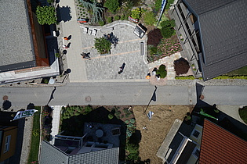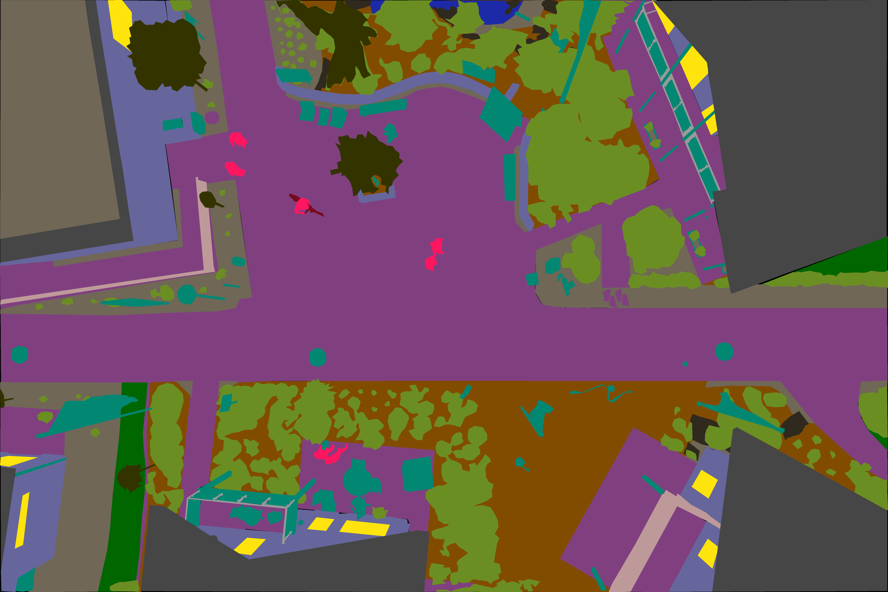

Team Members: Jacob Bowers, Zane Padgett, Dina Famouri, Yang Yan, and Yuxuan Wang.